**Advance Excel Assignment 4**

*1. To use the ribbon commands, what menu and grouping of commands will you find the Insert and Delete command?*

In Home menu and in the cells group.

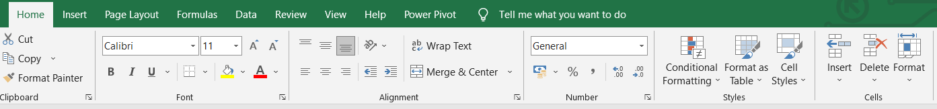

*2. If you set a row height or column width to 0 (zero), what happens to the row and column?*

Row or column get hide.

*3. Is there a need to change the height and width in a cell? Why?*

When copying data into Excel sheets, sometimes when a row height does not adjust automatically. As the result, multi-line or unusually tall text is clipped like shown on the right-hand part of the screenshot below.

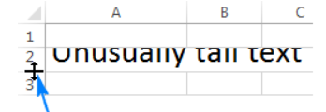

So to fit the date in the cell, We need to change the height and width in a cell.

*4. What is the keyboard shortcut to unhide rows?*

Press Ctrl + Shift + 9.

*5. How to hide rows containing blank cells?*

To hide rows that contain any blank cells, proceed with these steps:

1. Select the range that contains empty cells you want to hide.
2. On the Home tab, in the Editing group, click Find & Select > Go To Special.
3. In the Go To Special dialog box, select the Blanks radio button, and click OK. This will select all empty cells in the range.
4. Press Ctrl + 9 to hide the corresponding rows.

*6. What are the steps to hide the duplicate values using conditional formatting in excel ?*

1. Select the range you want to hide duplicates.

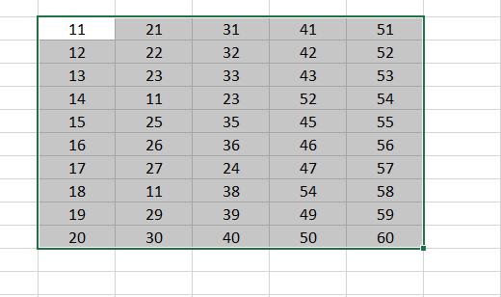

1. Then click Conditional Formatting > Highlight Cells Rules > Duplicate Values under Home tab.

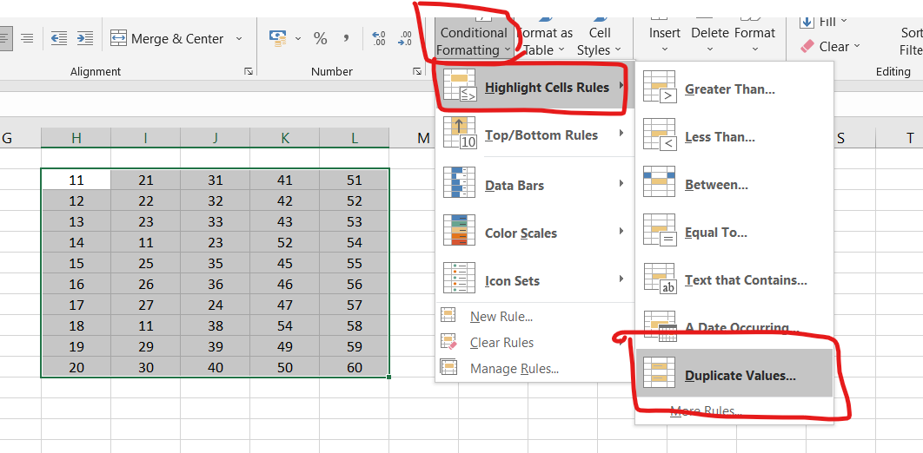

1. In the Duplicate Values dialog box, select Custom Format in the values with drop-down list, and then click the OK button.

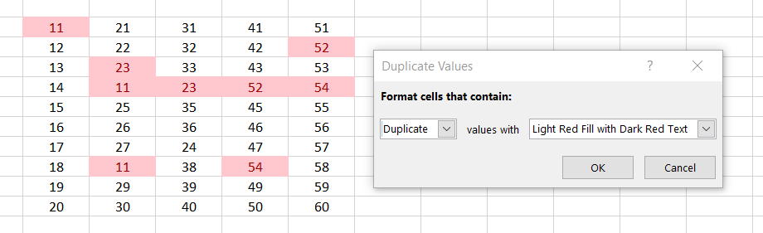

1. In the Format Cells dialog box, go to the Font tab, and in the Color drop-down list, choose a font color which matches the background color of your selected range cell. And finally click the OK button.

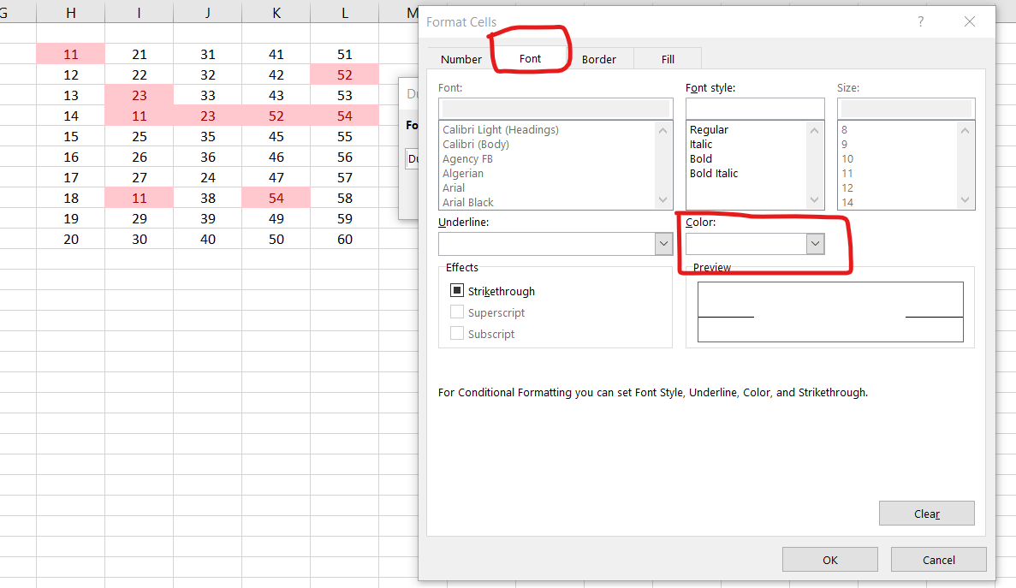

1. When it returns to the Duplicate Values dialog box, click the OK button.Now all duplicate records in selected columns are hidden immediately.

